How the Cost-of-Living Survey Helps Inform Your Pay
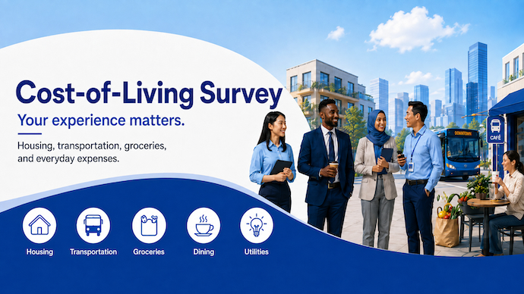
How much do you spend on housing, transportation, groceries, dining, utilities, and other everyday expenses? And how does that information help determine post adjustment? Through a Cost-of-Living survey.
The Cost-of-Living survey will take place in New York in September 2026.
This survey gives eligible staff an important opportunity to provide information about their household expenditures and helps to ensure that the post adjustment of New York and all duty stations worldwide accurately reflect the spending patterns of staff.
It is not just how much you spend, but how you spend it
One of the most important parts of the survey is the household expenditures questionnaire.
The purpose is not to determine how much staff spend overall. It is to understand how household spending is distributed across different categories.
For example, two households might spend the same amount each month but divide their spending very differently. These expenditure patterns help the International Civil Service Commission (ICSC) determine the relative importance, or weight, of the different goods and services included in the cost-of-living comparison.
The information provided by staff is then combined with prices collected for a specified basket of goods and services. Together, these data are used to update the post adjustment index for each duty station.
The accuracy of the survey depends to a large extent on the number of eligible staff who participate.
A strong response rate helps ensure that the expenditure patterns used in the calculations are representative of the staff who actually live and work at the duty station.
All eligible staff members in the Professional and higher categories (P-1 through D-2) and the Field Service category (FS-6 and FS-7) are therefore strongly encouraged to complete the questionnaire.
Cost-of-living surveys of this kind are conducted periodically, making each survey an important opportunity for staff to provide updated information about how their household spending has changed over the past few years.
What are the Questions?
The questionnaire covers a range of household expenditures, including areas such as housing, food, transportation, clothing, household goods, recreation and other goods and services.
It takes approximately 30 to 45 minutes to complete and is available in English, French and Spanish. Keep in mind that you can save your responses at any time and return later to complete the questionnaire.
Staff can also prepare in advance by using the expenditure diary available on the ICSC survey website in English and French. The diary can help you keep track of household expenses before completing the questionnaire.
Information provided through the survey will be treated as strictly confidential and processed by the ICSC only for the purpose of estimating average expenditure patterns.
What’s Next?
Eligible staff will receive an email with a direct link to the questionnaire and instructions for participating. You can also visit the dedicated ICSC Cost-of-Living survey website to learn more about how the survey works, access the questionnaire and view frequently asked questions.

Have Questions? Join the Webinar
Staff are invited to join a live webinar with the head of the ICSC survey team to learn more about the cost-of-living survey and ask questions directly.
Date: September 10, 2026
Time: 9:30 am EST
Link: https://teams.microsoft.com/meet/3119964973739?p=DEjcrSGaIpp5nWCRm0
Learn More at the ICSC Cost-of-Living survey website:
https://surveys.unicsc.org/COLD

